

Mariano Marcos State University

Database Systems

EMPLOYEE TRAINING MANAGEMENT SYSTEM

Final Project

Submitted to
JERWIN MARK L. GUILLERMO
Laboratory Instructor, CMPSC 116

Submitted by
DELA CRUZ, BERLENARD
DELOR CASA, MILES CRIZZAM ANNE
GALACGAC, DAN KARL ROSS
TULALI, MARC JEROME T.
BS in Computer Science II-A

Submitted on
23 December 2019

CHAPTER I

PROJECT DESCRIPTION

The Employee-Training Information System is a software that keeps track of what training has been attended by an employee that is stored in the database. This software is written in Java 1.8 with the Swing GUI Framework. The database used in this software is SQLite.
What makes this software different is that the features of this software are aligned with the needs of the Human Resource Office of the City Government of Batac as the Human Resource Officers requested the specific feature implementation.
The features are:
- CRUD Functionality of training information and its specific details are name of training, date, location, training sponsors and short training description.
- CRUD Functionality of an Employee Information (name, sex, birthdate) and it’s corresponding department and position.
- Generation of Reports of an employee training and attendees and non-attendees of a selected training.
This software is important because it improves the present organization of employee training data which are printed documents and a hard-to-manage large excel file with redundant data. This software removes the practice of manually sorting documents and scrolling an excel file with a lot of rows just to find training information of each employee.

CHAPTER II

DATABASE DESIGN

- Enterprise Narrative

Employees working in the government attends training for the purpose of promotion and extended knowledge to deliver task more organized and efficient. Human Resource Officers, the users of the view level of the database needs to know the personal information (full name, employee, sex, date of birth) of these employees and their respective department,positions and employee ID to know what training an employee has and what training an employee lacks. Each employee belongs in a department that is characterized by a department name.

A department provides positions for employees. Each department has many employees. An employee that belongs in a department can only have one position but a position can be given to many employees.

The trainings attended by an employee is charecterized by an ID, name of the training, date, location, and a description. These trainings can be sponsored by one or more sponsors which are characterized by their sponsor ID and name. These trainings can be attended by many employees. An employee can also attend one or more trainings.

- Entity-Relationship Diagram

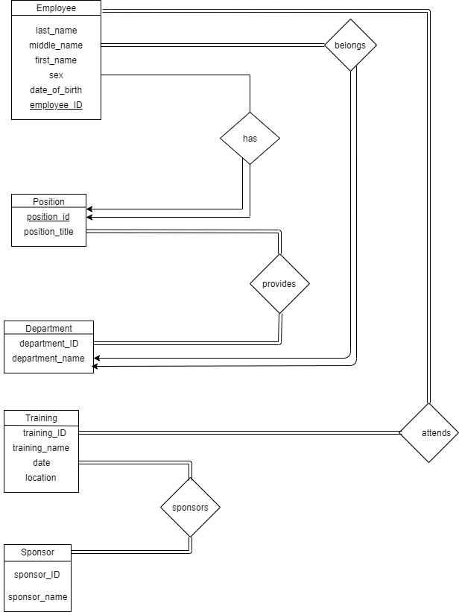

- Relational Schema Diagram
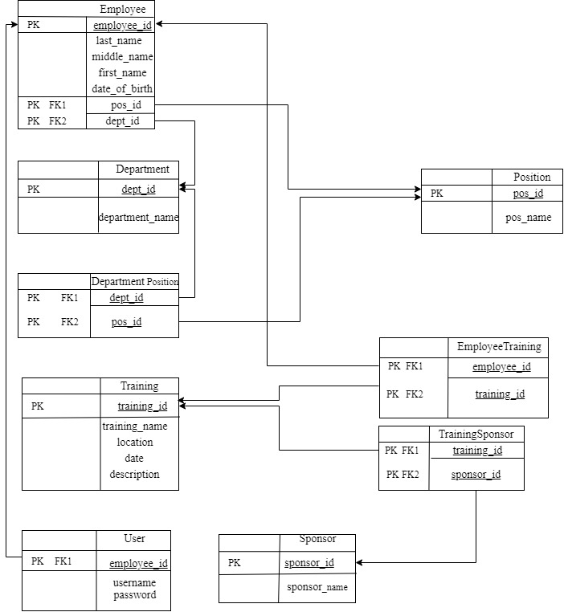

- Data Dictionaries

Data Dictionary for Employee
Field Name | Data Type | Field Size | Primary Key | References | Description | Example
employee_id | Integer |  | Yes |  | Unique number ID for all employees | 1
last_name_ | Varchar | 50 | No |  | Employee’s lastname | De la Cruz
first_name | Varchar | 50 | No |  | Employee’s first name | Juan
middle_name | Varchar | 50 | No |  | Employee’s middle name | Luna
sex | Varchar | 6 | No |  | Employee’s sex | Male
date_of_birth | Date |  | No |  | Employee’s date of birth | 08/05/1972
pos_id | Integer |  | No | Position | Employee’s position id | 1
dept_id | Integer |  | No | Department | Employee’s department id | 2

Data Dictionary for Department
Field Name | Data Type | Field Size | Primary Key | References | Description | Example
dept_id | Integer |  | Yes |  | Unique number ID for all departments | 1
department_name | Varchar | 100 | No |  | Name of Department | Human Resource Office

Data Dictionary for Position
Field Name | Data Type | Field Size | Primary Key | References | Description | Example
pos_id | Integer |  | Yes |  | Unique number ID for all positions | 1
pos_title_ | Varchar | 100 | No |  | Title of position | Administrative Aide IV

Data Dictionary for Training
Field Name | Data Type | Field Size | Primary Key | References | Description | Example
training_id | Integer |  | Yes |  | Unique number ID for all trainings | 1
training_name_ | Varchar | 200 | No |  | Name of training | Django Web Development
training_date | Date |  | No |  | Date of training | 08/05/2019
location | Varchar | 75 | No |  | Location of training | GT-Toyota Asian Center and NISMED, UP Diliman
description | Text |  | No |  | Description of training | Training for BSCS students

Data Dictionary for Sponsor
Field Name | Data Type | Field Size | Primary Key | References | Description | Example
sponsor_id | Integer |  | Yes |  | Unique number ID for all sponsors | 1
sponsor_name | Varchar | 100 | No |  | Name of Sponsor | Department of Science and Technology

Data Dictionary for EmployeeTraining
Field Name | Data Type | Field Size | Primary Key | References | Description | Example
employee_id | Integer |  | Yes | Employee | Unique number ID for all employees | 1
training_id | Integer |  | Yes | Training | Unique number ID for all trainings | 1

Data Dictionary for TrainingSponsor
Field Name | Data Type | Field Size | Primary Key | References | Description | Example
training_id | Integer |  | Yes | Training | Unique number ID for all trainings | 1
sponsor_id | Integer |  | Yes | Sponsor | Unique number ID for all sponsor | 1

Data Dictionary for DepartmentPosition
Field Name | Data Type | Field Size | Primary Key | References | Description | Example
dept_id | Integer |  | Yes | Department(dept_id) | Unique number ID for all departments | 1
pos_id | Integer |  | Yes | Position (pos_id) | Unique number ID for all positions | 1

Data Dictionary for User
Field Name | Data Type | Field Size | Primary Key | References | Description | Example
employee_id | Integer |  | Yes | Employee | Unique number ID for all employees | 1
username | Varchar | 15 | No |  | User’s username | adminHR123
password | Varchar | 100 | No |  | User’s password | ADMINhr321

CHAPTER III
SOURCE CODES

- APPLICATION

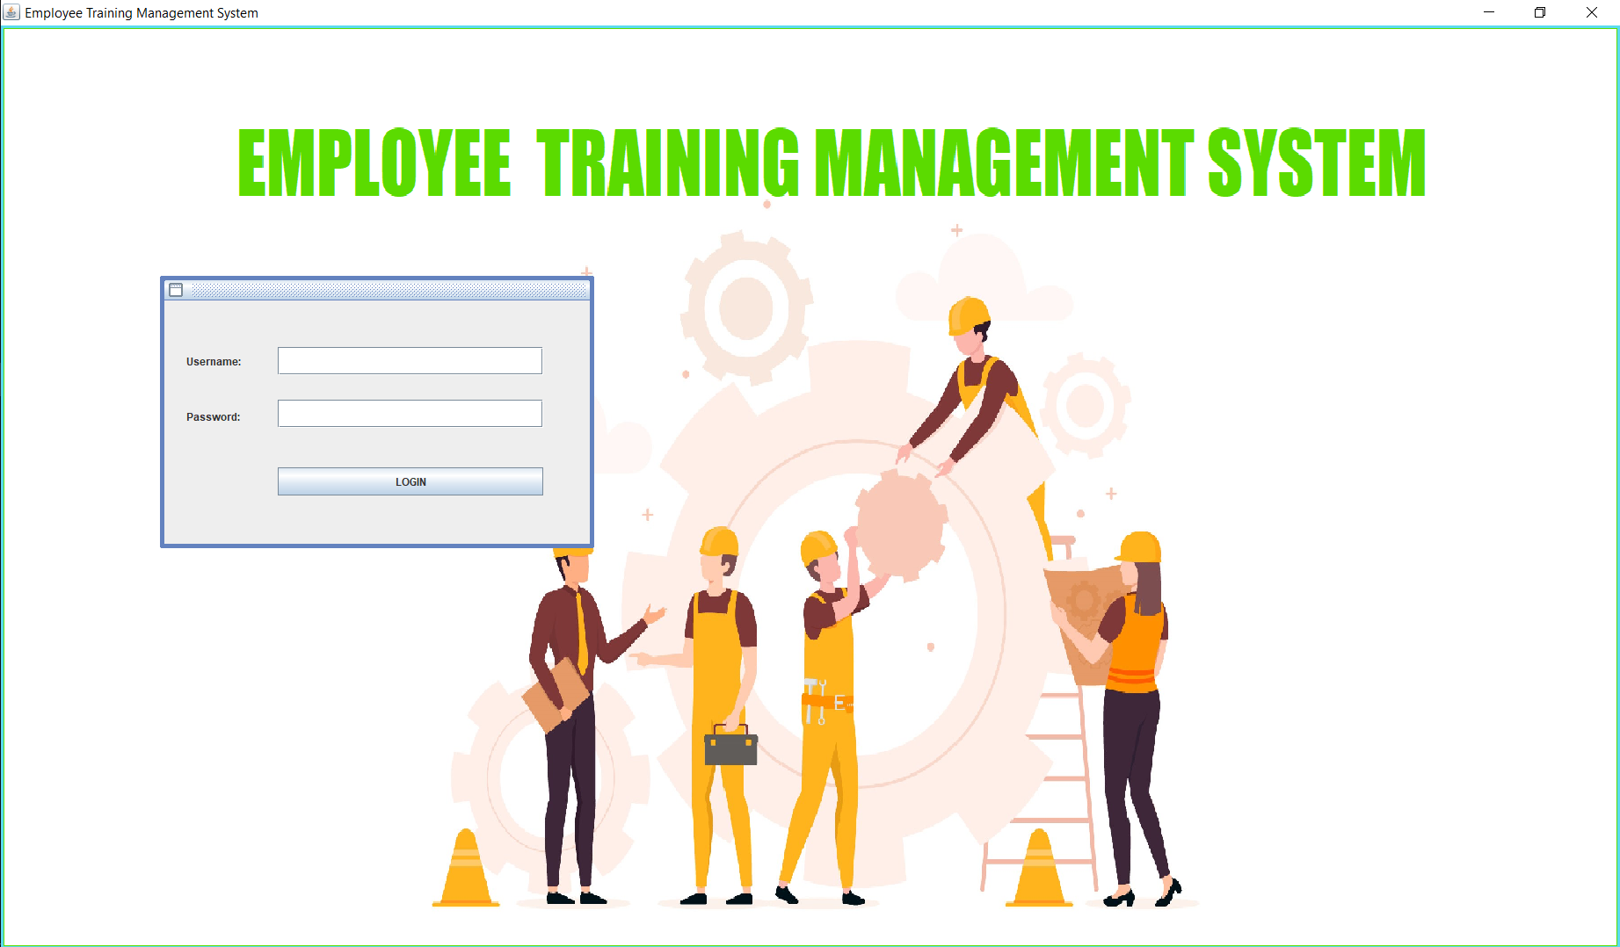

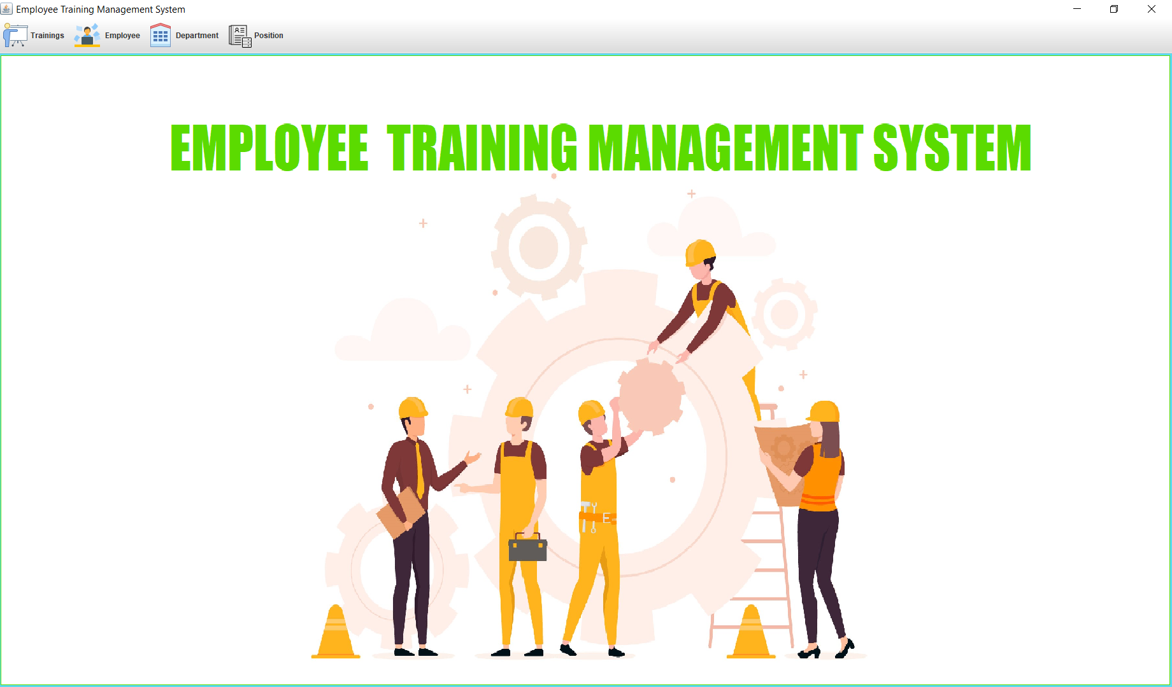

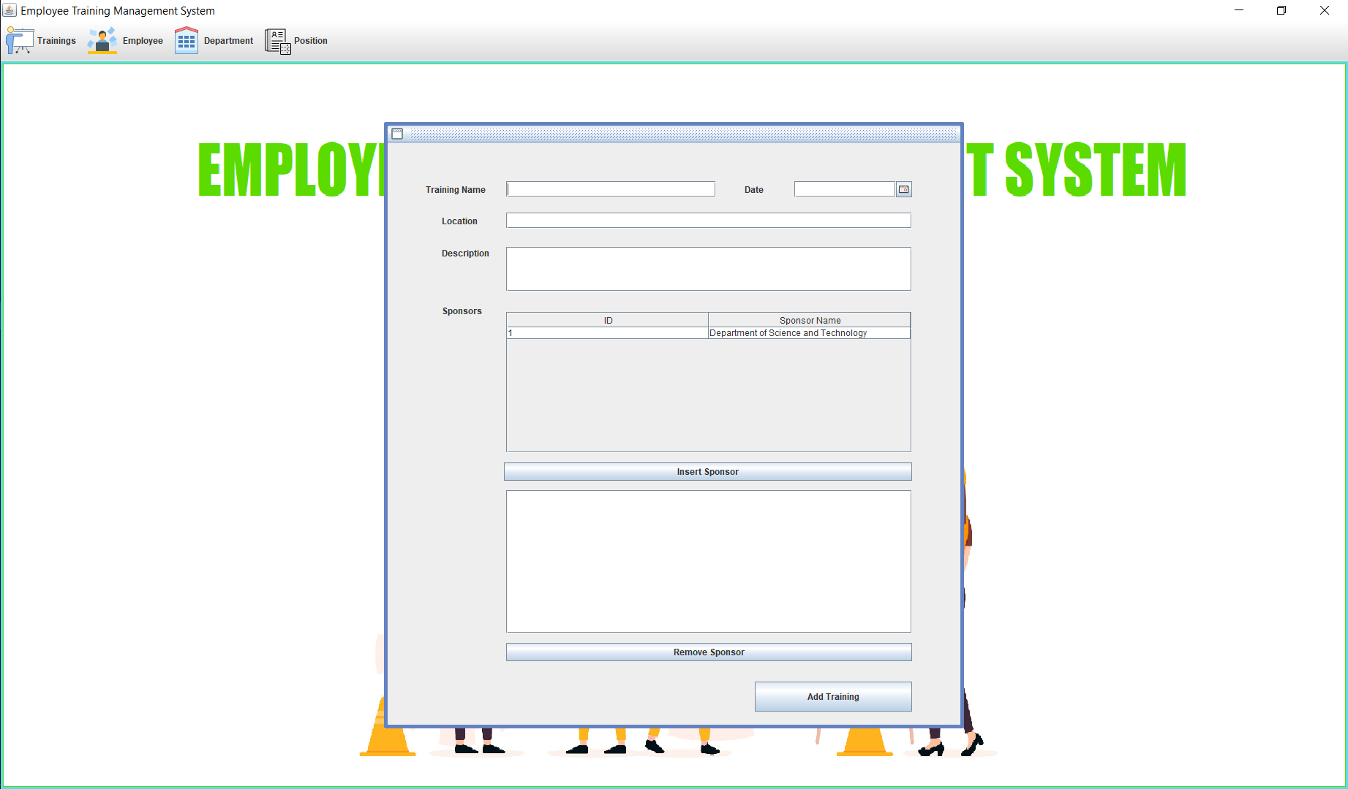

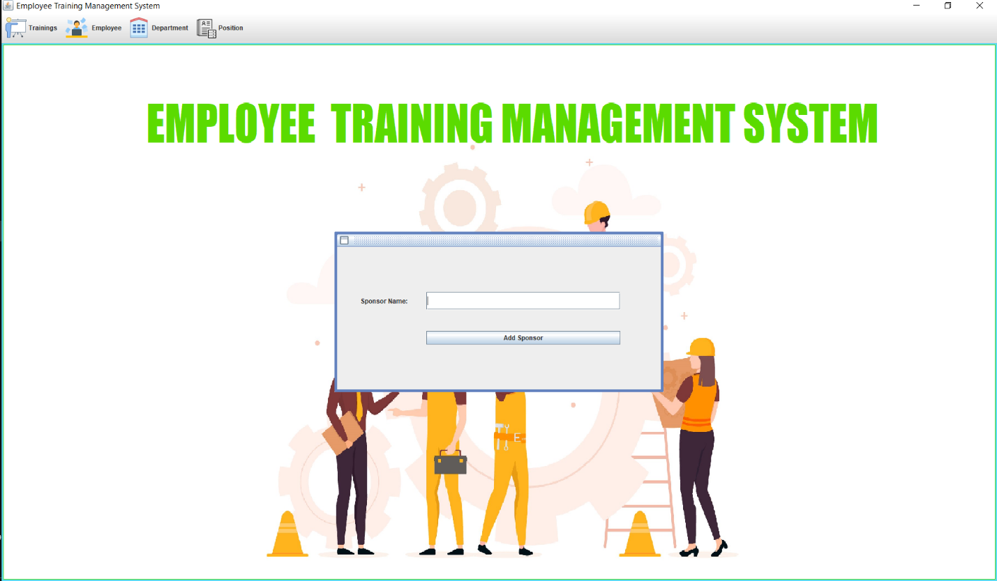
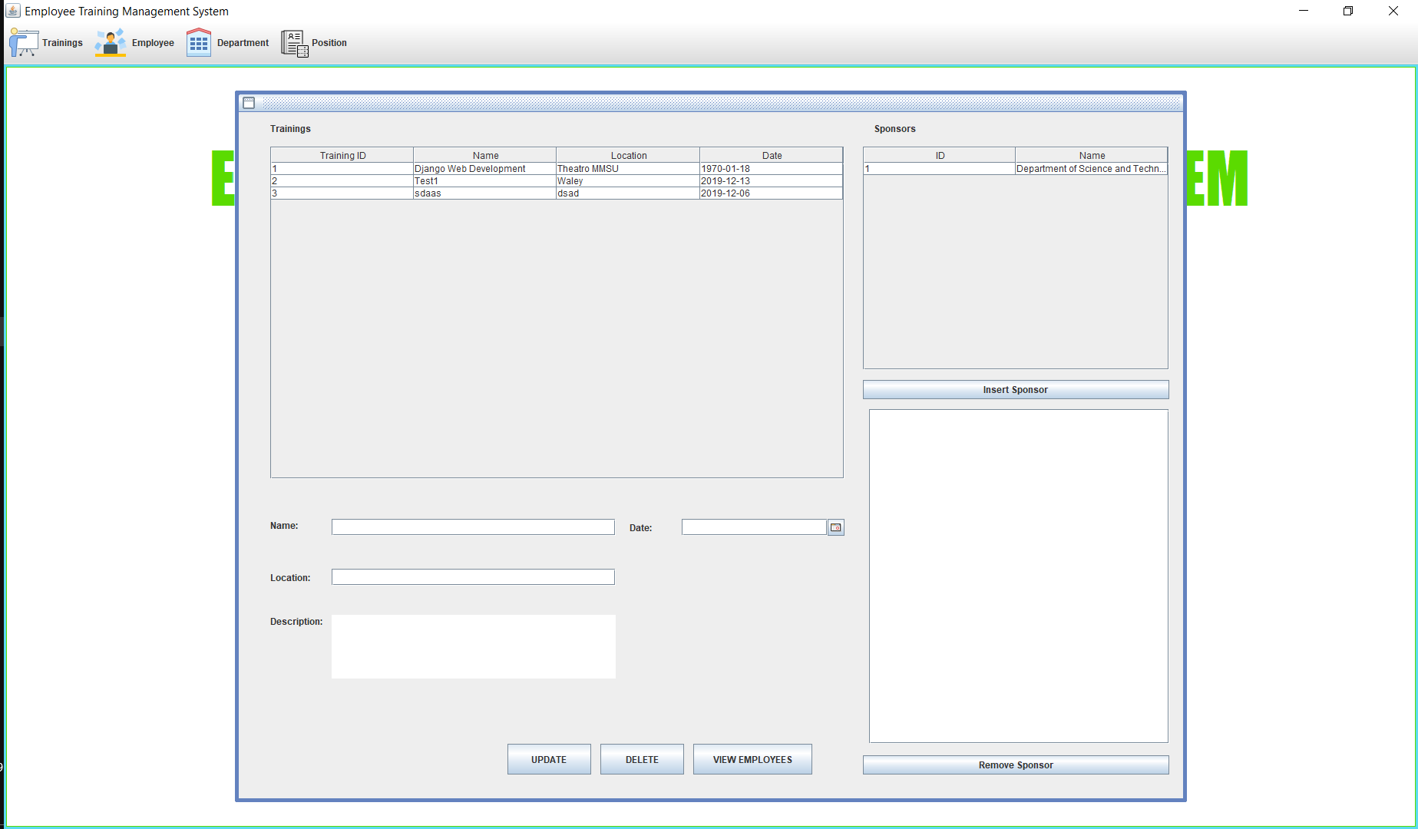

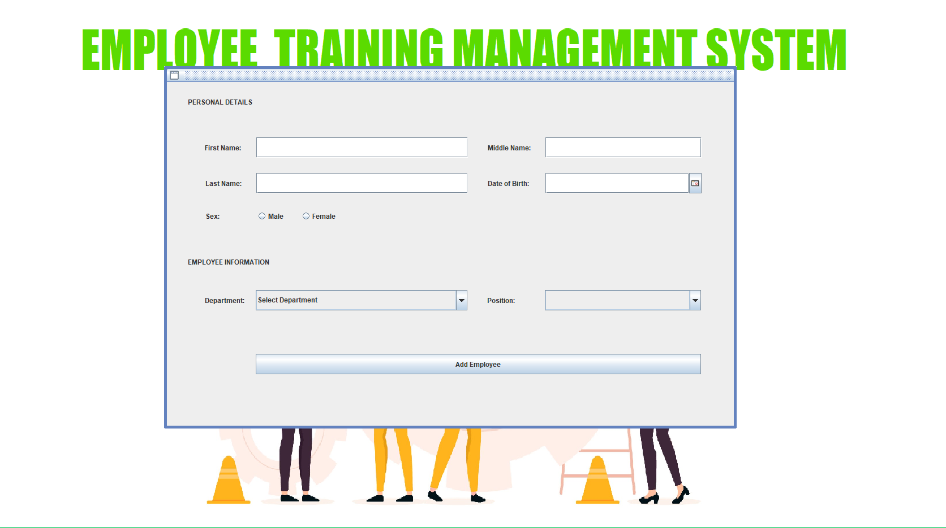

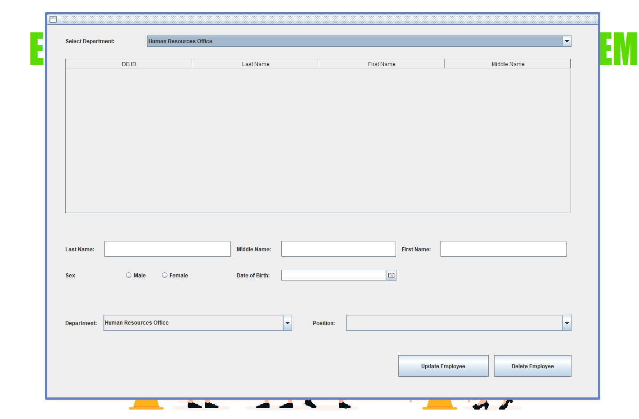

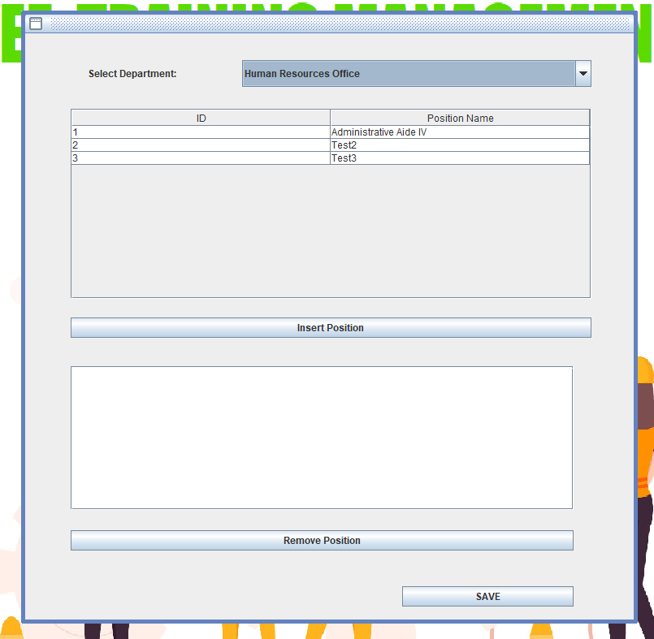

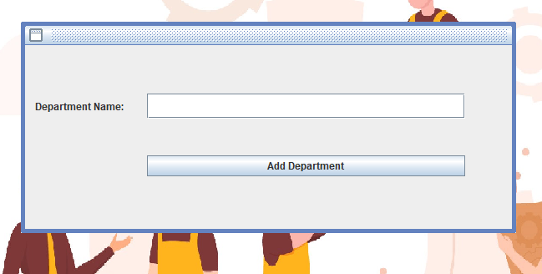

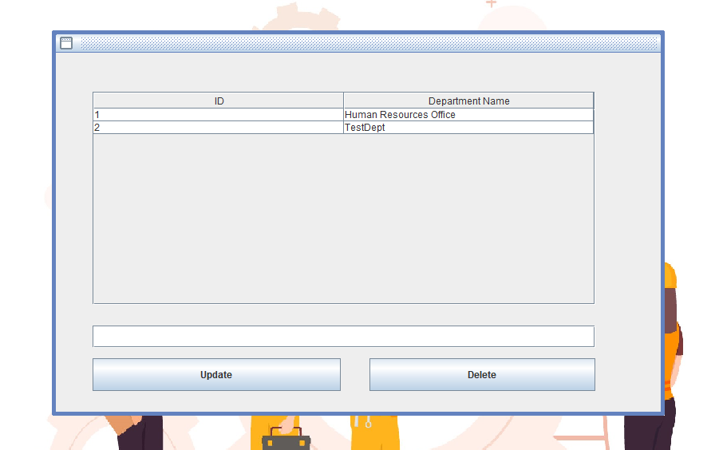

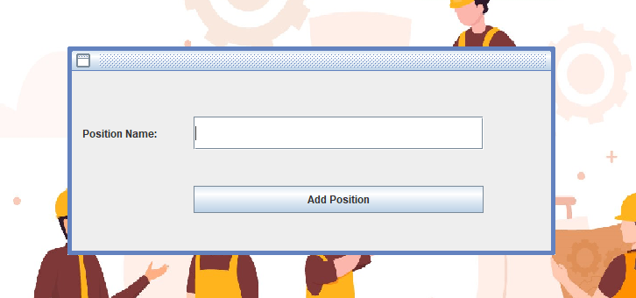

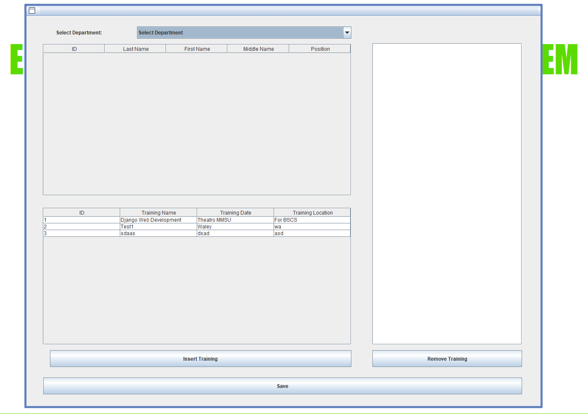

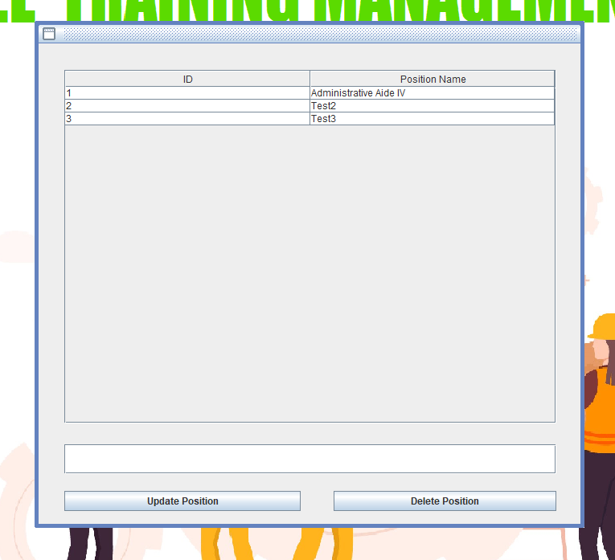
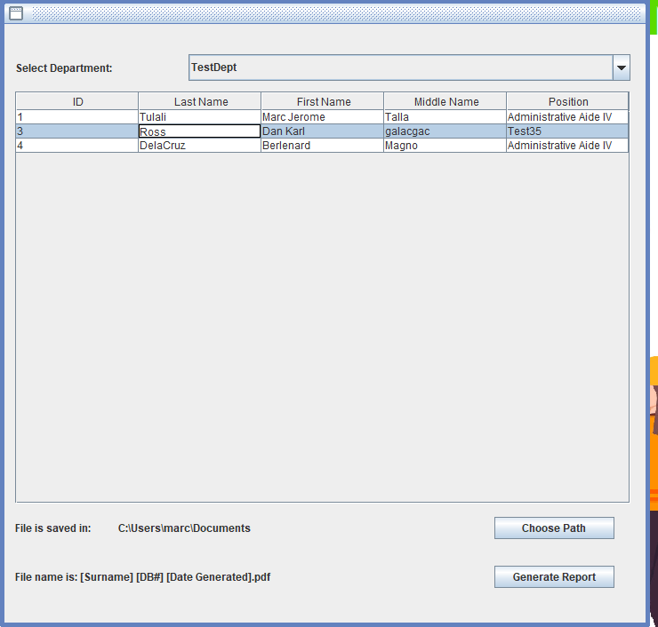
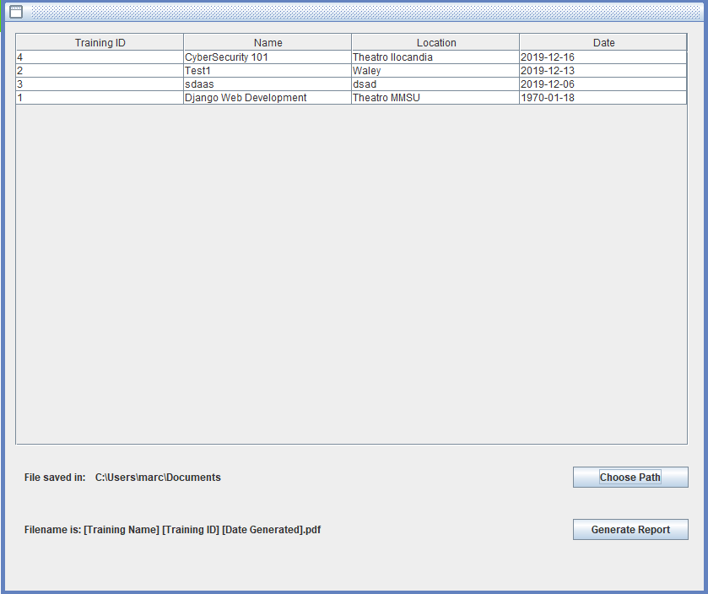
B. SQL DATA-DEFINITION LANGUAGE
1  2  3  4  5  6  7  8  9  10  11  12  13  14  15  16  17  18  19  20  21  22  23  24  25  26  27  28  29  30  31  32  33  34  35  36  37  38  39  40  41  42  43  44  45  46  47  48  49  50  51  52  53  54  55  56 | CREATE TABLE Department(  dept_id INTEGER PRIMARY KEY,  department_name VARCHAR(100) NOT NULL UNIQUE  );  CREATE TABLE 'Position'(  pos_id INTEGER PRIMARY KEY,  pos_title VARCHAR(100) NOT NULL UNIQUE  );  CREATE TABLE Employee (  employee_id INTEGER PRIMARY KEY,  first_name VARCHAR(50),  middle_name VARCHAR(50),  last_name VARCHAR(50),  sex CHAR(1),  date_of_birth DATE,  pos_id INTEGER,  dept_id INTEGER,  FOREIGN KEY (pos_id) REFERENCES "Position" (pos_id),  FOREIGN KEY (dept_id) REFERENCES Department (dept_id)  );  CREATE TABLE Training(  training_id INTEGER PRIMARY KEY,  training_name VARCHAR(200),  training_date DATE,  training_location VARCHAR(75)  );  CREATE TABLE Sponsor(  sponsor_id INTEGER PRIMARY KEY,  sponsor_name VARCHAR(100)  );  CREATE TABLE TrainingSponsor(  training_id INTEGER,  sponsor_id INTEGER,  PRIMARY KEY (training_id, sponsor_id),  FOREIGN KEY (training_id) REFERENCES Training (training_id),  FOREIGN KEY (sponsor_id) REFERENCES Sponsor (sponsor_id)  );  CREATE TABLE "User"(  employee_id INTEGER PRIMARY KEY,  username VARCHAR(15) NOT NULL UNIQUE,  password VARCHAR(100),  FOREIGN KEY (employee_id) REFERENCES Employee (employee_id)  );  CREATE TABLE DepartmentPosition(  dept_id INTEGER,  pos_id INTEGER,  PRIMARY KEY (dept_id, pos_id),  FOREIGN KEY (pos_id) REFERENCES "Position" (pos_id),  FOREIGN KEY (dept_id) REFERENCES Department (dept_id)  );  CREATE TABLE EmployeeTraining(  employee_id INTEGER,  training_id INTEGER,  PRIMARY KEY (employee_id, training_id),  FOREIGN KEY (employee_id) REFERENCES Employee (employee_id),  FOREIGN KEY (training_id) REFERENCES Training (training_id)  );

- SQL INSERT OPERATIONS (FOR INITIAL DATA)

1  2  3  4  5  6  7  8  9  10  11  12  13  14  15  16  17  18  19  20  21  22  23  24  25 | INSERT INTO Department(department_name) VALUES("Human Resources Office")  INSERT INTO "Position"(pos_title) VALUES("Administrative Aide IV")  INSERT INTO Sponsor(sponsor_name) VALUES("Department of Science and Technology")  INSERT INTO Training(training_name,training_date,training_location,training_description) VALUES("Django Web Development", "1483200000", "Theatro MMSU", "For BSCS")  INSERT INTO Employee(first_name,middle_name,last_name,sex,date_of_birth,pos_id,dept_id) VALUES("Marc Jerome", "Talla", "Tulali", "Male", "2007-01-01 10:00:00", 1, 1)  INSERT INTO DepartmentPosition(dept_id,pos_id) VALUES(1,1)  INSERT INTO EmployeeTraining(employee_id,training_id) VALUES(1,1)  INSERT INTO TrainingSponsor(training_id,sponsor_id) VALUES(1,1)  INSERT INTO "User"(employee_id, username,password) VALUES(1,"admin", "admin1")

CHAPTER IV
MANUAL
TABLE OF CONTENTS
1. MANAGING POSITIONS
  - How to add positions………………………………………………...89
  - How to edit positions………………………………………………..90
  - How to delete positions……………………………………………...91

2. MANAGING DEPARTMENTS
2.1 How to add departments…………………………………………….92
2.2 How to add positions to department………………………………...93
2.3 How to delete positions to department ……………………………...94
2.4 How to edit department……………………………………………...95
2.5 How to delete department…………………………………………...96

3. MANAGING EMPLOYEE
3.1 How to add employee……………………………………………….97
3.2 How to edit employee……………………………………………….98
3.3 How to delete employee……………………………………………..99
3.4 How to insert training on employee………………………………..100
3.5 How to remove a training from a employee……………………….101

4. MANAGING TRAINING
4.1 How to add trainings………………………………………………102
4.2 How to add trainings and insert sponsor/s…………………………103
4.3 How to add sponsor………………………………………………...104
4.4 How to edit training/s………………………………………………105
4.5 How to delete training/s……………………………………………106
4.6 How to view employees attending the trainings…………………...107

5. REPORTS
5.1 How to generate report and export an employee-training to pdf…..108
5.2 How to generate report and export a attendees and non-attendees of a training to pdf………………………………………………………109

1. MANAGING POSITIONS
  - How to add positions:
First press on the position icon and hover your pointer on it, and then press the add position button below the icon button and type the position name.
- 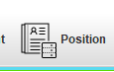
(2. 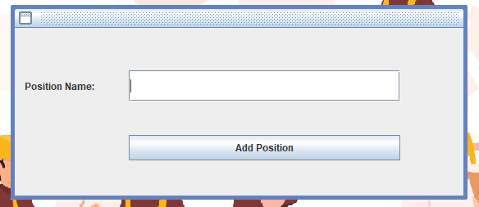

  - How to edit positions:
Press the position button and then press the view positions below the position icon, then double click on the position that you want to change and type the position you prefer and click the update position button below to save your update.
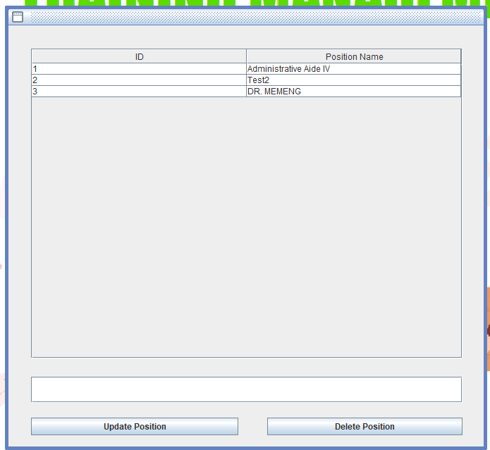

  - How to delete positions:
Press the position button and then press the view positions below the position icon, the click on the position you want to delete and press the delete position button below to delete the position.

2. MANAGING DEPARTMENT
2.1 How to add department
Press the department button and then press the add department button, then type your preferred name of department.
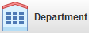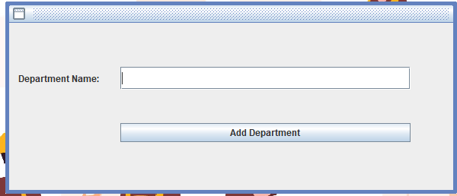

2.2 How to add position to department
Press the department button then press manage department position below the department button, then select a department that you would like to insert a position in and then press on that position that you would like to insert then press then press insert button.

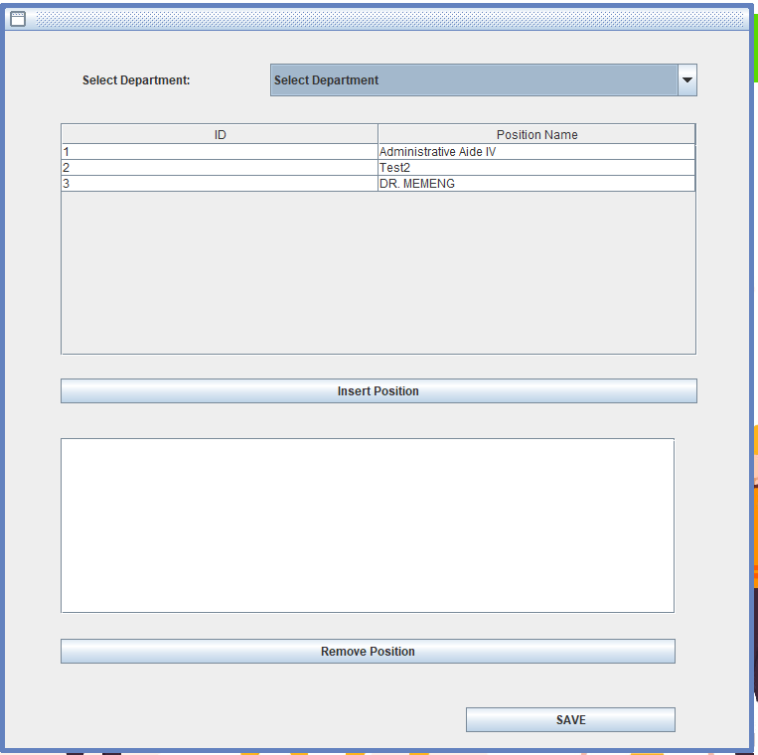

2.3 How to delete position to department
Press the department button then press manage department position below the department button, then select a department that you would like to delete the position on, then press the position on the window below and press the remove position button.

2.4 How to edit department
Press the department button and then press the view departments below the department icon, then click on the department that you want to change and type the department you prefer and click the update button below to save your update.
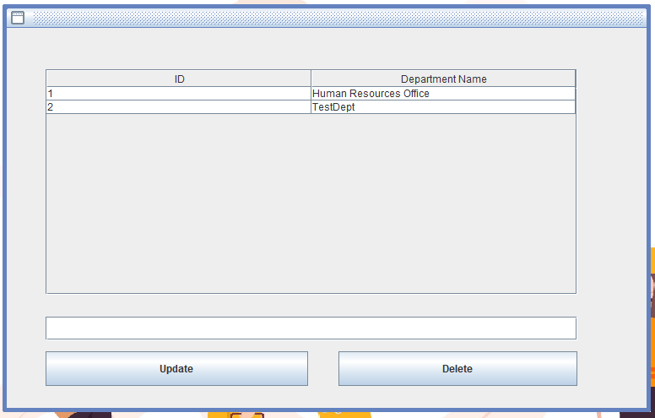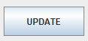

2.5 How to delete department
Press the department button and then press the view departments below the department icon, then click on the department you want to delete and press the delete button below to delete the department.

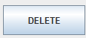


- MANAGING EMPLOYEE

3.1 How to add employee
Click on the employee button and press the add employee below the employee icon and type the employee’s name, fill up the rest of the form. After that, click on ‘Add Employee’

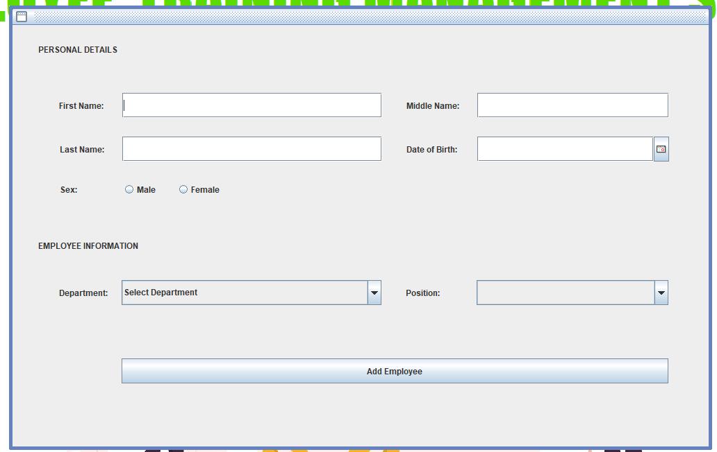

3.2 How to edit employee
Click on the employee button then press the image\view employee button below the employee icon, then first select which department is the employee from and press on the employee that you want to update its information, now that you found the employee you can edit its information (last name, middle name, first name, gender, and date of birth) then press the update employee button.
.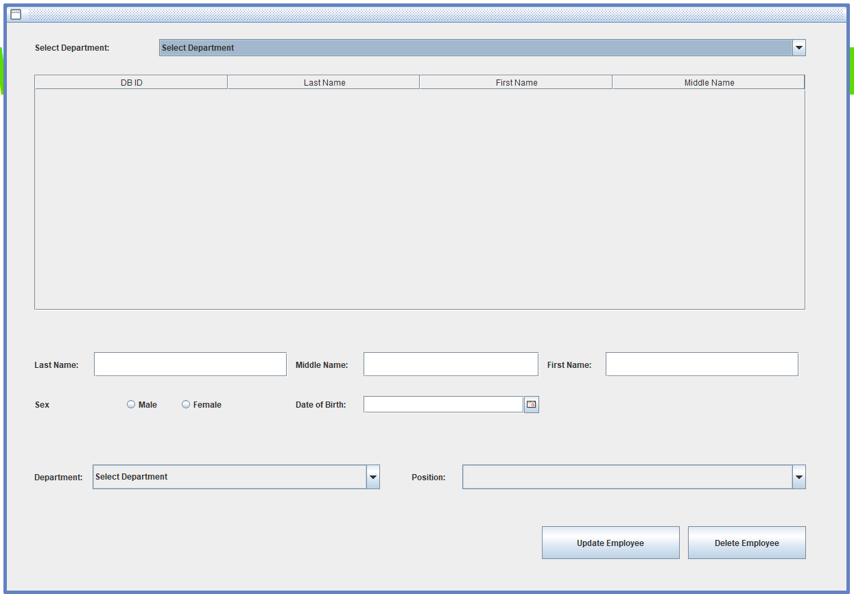
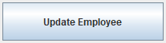

3.3 How to delete employee
Click on the employee button then press the img\view employee button below the employee icon, then first select which department is the employee from and press on the employee that you want to delete, then press the delete employee button.

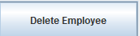

3.4 How to insert training on employee
Click on the employee button then press the view employee training button below the employee icon, then select the department where the employee you want to insert a training is from then select the employee and select the training that you want the employee to take, then press the insert training button.

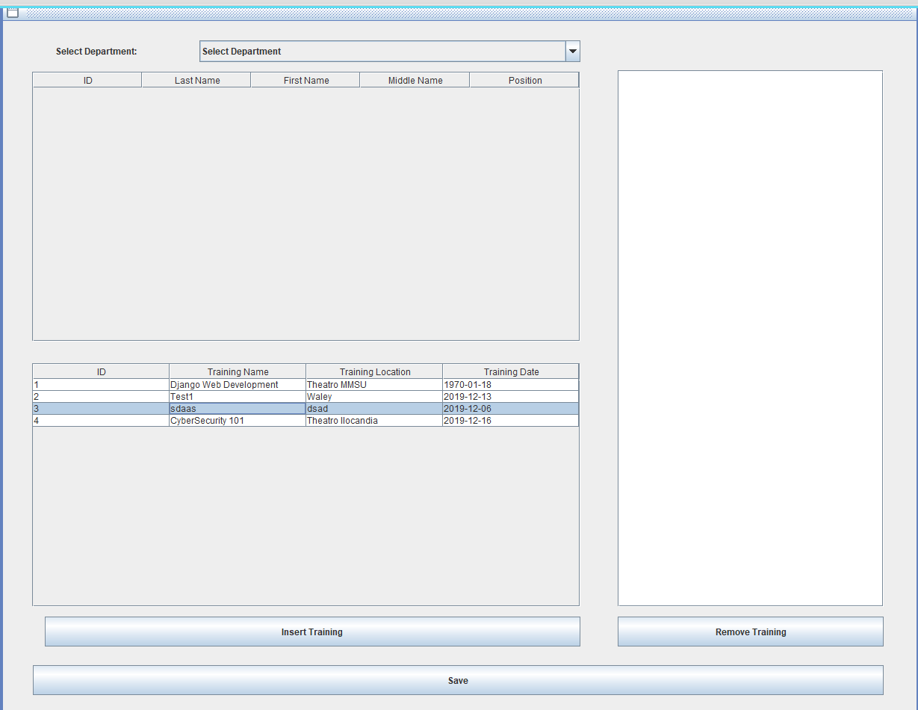

3.5 How to remove a training from an employee
Click on the employee button then press the view employee training button below the employee icon, then select the department where the employee is from, then click on the training/s that the employee is taking that you want to delete (right window) and press the remove training button.

4. MANAGING TRAININGS
4.1 How to add training
Click on the training button and press the add training button below the training icon, then fill up the information needed in the blanks then press the add training button

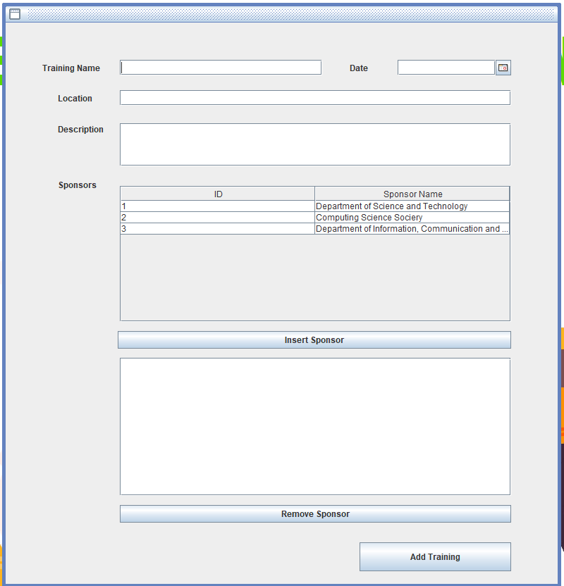
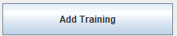

4.2 How to add training and insert/remove sponsors
Click on the training button and press the add training button below the training icon, then fill up the information needed in the blanks and click on the sponsors you want to add to that training in the sponsors window, then press insert sponsor. And if you want to remove sponsor/s just press the sponsor that you want to remove then press the remove sponsor button, if you already fill up this information you can now press the add sponsor button.

4.3 How to add sponsor
Click on the training button and press the add sponsor button below the training icon, then type the sponsor that you want to add, then press the add sponsor button.
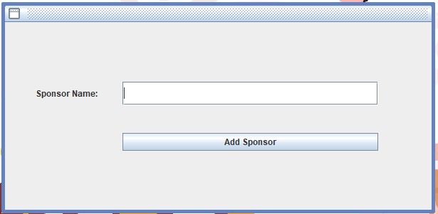

4.4 How to edit training/s
Click on the training button and press the view trainings button below the training icon, then select the training that you want to edit and after finishing editing it you can press the update button.
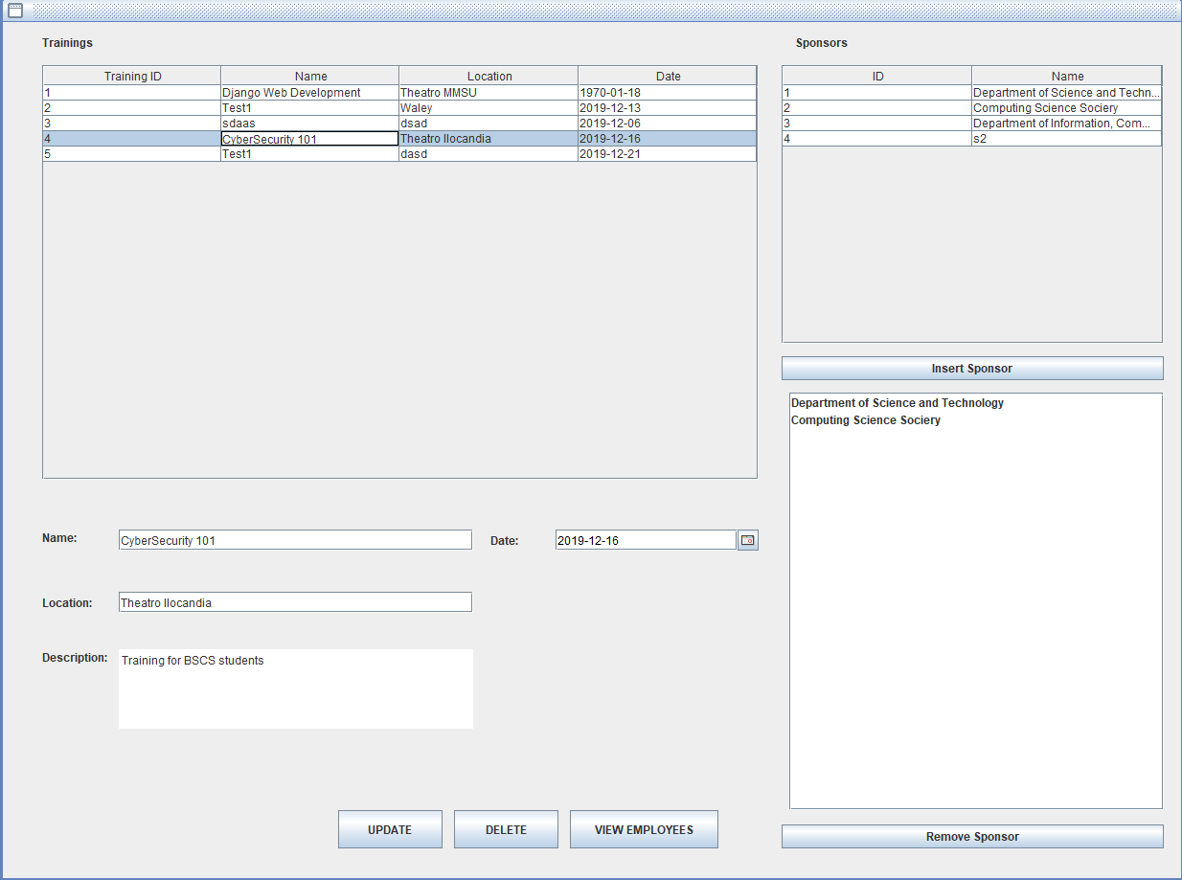
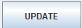

4.5 How to delete trainings
Click on the training button and press the view trainings button below the training icon, then select the training that you want to delete then press the delete button

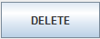

4.6 How to view employees attending the training/s
Click on the training button and press the view trainings button below the training icon, then select the training that you want to view and press view employees.
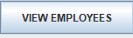

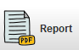
5. REPORTS

5.1 How to generate report and export an employees training to pdf.
Click on the report button then press the training of an employee below the report icon, then choose a training and choose the path then press the generate report button.

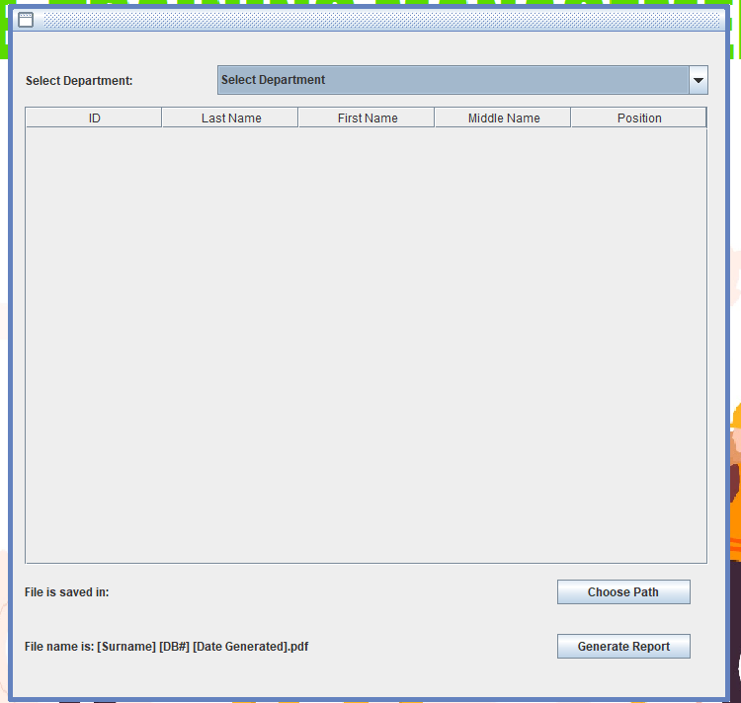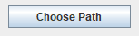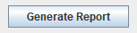

5.2 How to generate report and export a attendees and non-attendees of a training to pdf
Click on the report button then press the attendees and non-attendees of a training
Below the report icon, then choose a training and choose the path then press the generate report button.

